No. | Answer
n(Na₂CO₃) = c × V = 0.0500 × 0.250 = 0.0125 mol
m(Na₂CO₃) = n × M = 0.0125 × 105.99 = 1.325 g
1 Accurately weigh approximately 1.3 g sample of the primary standard.
2 Transfer the sample to a 250.0 mL volumetric flask.
3 Ensure complete transfer by washing with water.
4 Dissolve the primary standard in water by swirling the flask.
5 Add water to make up the solution to the calibration mark, then mix thoroughly.
 | The sodium hydroxide is very concentrated. An exact concentration cannot be calculated from the data available.
The ratio of volumes is 20:5 or 1:4. This means the sodium hydroxide is four times more concentrated than the nitric acid. Therefore the concentration is 0.4 mol L^{–1}.
This ratio only works if the molar ratio of acid and base in the balanced equation is 1:1.
a 2HNO₃(aq) + Na₂CO₃(aq) → 2NaNO₃(aq) + H₂O(l) + CO₂(g)
b n(HNO₃) = c × V = 0.10 × 0.040 = 0.00400 mol
n(Na₂CO₃) =  × n(HNO₃) = 0.00200 mol
V(Na₂CO₃) = 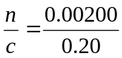 = 10 mL
a HCl(aq) + NH₃(aq) → NH₄⁺(aq) + Cl–(aq)
b i At the equivalence point, some NH₄⁺ exists. This is a weak acid; hence the pH will be about 5.
ii After excess HCl is added, the pH is slightly greater than 1. (pH of the acid is 1. The acid will be diluted by the increased volume due to the neutralised ammonia solution, giving a concentration less than 0.1 M and so a pH greater than 1.)
iii | 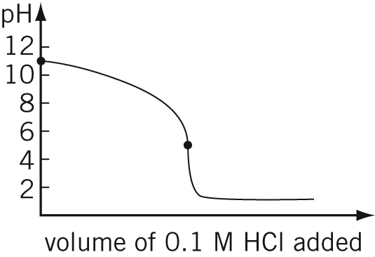

CH₃COOH(aq) + NaOH(aq) → CH₃COONa(aq) + H₂O(l)
n(NaOH) = c × V = 0.114 × 0.015 45 = 0.001 761 mol
n(CH₃COOH) = n(NaOH)
n(CH₃COOH) in original 25.0 mL = n(CH₃COOH) in aliquot × 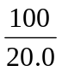 = 0.008 810 mol
c(CH₃COOH) = 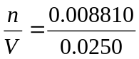 = 0.352 mol L^{–1}
Back titrations are performed when the substance to be analysed is:
- insoluble
- volatile (so the titration method is not fast enough to carry out the analysis before the concentration of the solution changes as evaporation occurs)
- a weak acid or a weak base (it is sometimes difficult to obtain sharp endpoints in these titrations).
a | 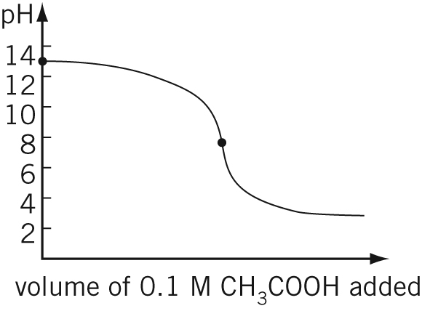
b CH₃COO– is present at the equivalence point. This weak base will mean that the pH will be above 7 at the equivalence point.
c An indicator such as methyl red would be a poor choice because it does not change colour until pH 3, long after the equivalence point has been reached.

a i Water
ii Solution going into it—hydrochloric acid
iii Solution going into it—sodium carbonate
iv Water
One method to try with this style of question is to picture a very exaggerated amount of water in the piece of glassware and to ask whether this will affect the experiment in any way.
b 2HCl(aq) + Na₂CO₃(aq) → 2NaCl(aq) + H₂O(l) + CO₂(g)
n(Na₂CO₃) = c × V = 0.100 × 0.0183 = 0.001 830 mol
n(HCl) = 2 × n(Na₂CO₃) = 2 × 0.001 830 = 0.003 660 mol
n(HCl) in original 10.0 mL = n(HCl) in aliquot × 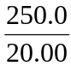
= 0.003 660 × = 0.045 80 mol
c(HCl) = 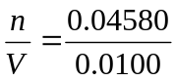 = 4.58 mol L^{–1}
2HNO₃(aq) + Mg(OH)₂(aq) → Mg(NO₃)₂(aq) + 2H₂O(l)
n(Mg(OH)₂) = c × V = 0.10 × 0.0250 = 0.002 50 mol
n(HNO₃) = 2 × n(Mg(OH)₂) = 2 × 0.002 50 = 0.005 00 mol
c(HNO₃) = 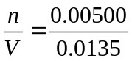 = 0.37 mol L^{–1}

